
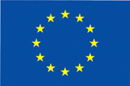
European Union Republic of Korea
Delegation of
the European Commission
Seoul
Ministry of
Information and
Communication

INVITATION

The Delegation of the EU Commission to Korea and the Ministry of Information and Communication cordially invite you to a Conference on EU-Korea Collaboration in Embedded Systems.

Date: 20th April 2005
Venue: Lotte Hotel (Sogong-dong), Emerald Room
Registration Fee: Free of Charge
Korean/English interpretation will be provided.

Organised by Delegation of the EU Commission Seoul &
Ministry of Information and Communication
In Collaboration with the Federation of Korean Information Industries, Korea Embedded Software Industry Council & ETRI
Programme Attached

R.S.V.P.

There is no registration fee, but registration will be accepted on a first-come, first-served basis as space may be limited.

I will attend. ( )

I cannot attend. ( )

Name : Company :

Tel : Fax:

E-mail:

Please confirm your participation to
Delegation of the European Union Commission Seoul
by fax (02.739.3514) or e-mail (Dayoung.Chung@delkor.cec.eu.int)
no later than April 15.

09:00 ~ 09:30 Registration
09:30 ~ 09:40 Opening remarks by Ambassador Dorian Prince
(Delegation of the European Union Commission Seoul)
09:40 ~ 09:50 Welcoming remarks by Minister of Information and Communications (TBC)

10:00 ~ 12:15 Session 1 Perspectives on Embedded Systems
Coordinator: Ki-Chul Kim, Secretariat of KESIC
10:00 ~ 10:40 ARTIST2, European Network on Embedded Systems
(Joseph Sifakis, Verimag, France)
10:40 ~ 11:20 ETRI’s R&D program in embedded software
(KIM Heung-Nam, Embedded Software Research Division, ETRI)
11:20 ~ 12:00 DECOS, Dependable Embedded Components and Systems
(Hermann Kopetz, Technical University of Vienna, Austria)
12:00 ~ 12:15 Q&A

12:15 ~ 13:30 Lunch offered by the Delegation of the EU Commission

13:30 ~ 14:40 Session 2 Automotive Challenges
Coordinator: Tom Clausen, European Commission
13:30 ~ 14:00 Automotive Challenges, EU Case
(Yunming WANG, Esterel Technologies)
14:00 ~ 14:30 Automotive Challenges
(Hyundai Autonet, TBC)
14:30 ~ 14:40 Q&A

14:40 ~ 15:00 Coffee Break

15:00 ~ 17:10 Session 3 EU-Korea Collaboration
Coordinator: Ki-Chul Kim, Secretariat of KESIC
15:00 ~ 15:30 Status and opportunity in Korea
(MIC Director or PM)
15:30 ~ 16:00 The IST Programme, Status and Opportunities
(Tom CLAUSEN, European Commission)
16:00 ~ 16:30 Prospect of EU-Korea Collaboration
(Professor KIM Moon-shik, Kunkook University, TBC)
16:30 ~ 17:00 Advanced Research and Technology for
Embedded Intelligence & Systems
(Dominique POTIER, Thales)
17:00 ~ 17:10 Q&A

17:10 ~ 17:15 Closing Remarks

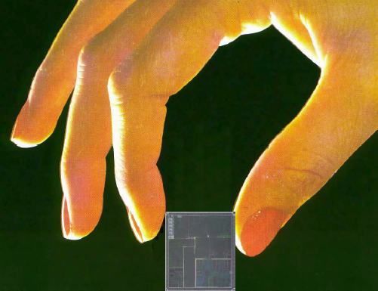
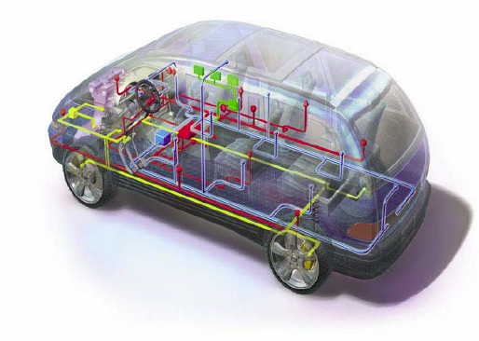
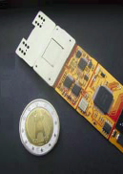

The purpose of this workshop is to identify important topics in the area of Embedded Systems where strong synergy between Korean and EU teams would have the greatest benefit. The aim is to achieve a common understanding and background on which future collaborative actions and joint projects can be based.
The workshop demonstrates the growing cooperation between Korea and the EU since the Framework Agreement on Trade and Co-operation entered into force in April 2001, in particular in the field of information technology considered by both partners as an industrial growth engine.
Embedded systems are computer or communications technology that is placed inside appliances and machines to enable them to carry out a certain function through wireless communication or via sensor or control capabilities.
Industrial machines, cars, medical equipment, cameras, household appliances, aircraft, vending machines, toys, mobile phones and PDAs are just some of the products in which embedded systems can be used.
The strong and increasing penetration of embedded systems in products and services creates new business opportunities for enterprises. Embedded intelligence provides comfort, safety and productivity growth to a growing number of industrial sectors. However, the increasing system complexity and market shifts are constant challenges that need new and radical scientific and technical solutions.
The workshop will bring together high level researchers from industry and academia with policy representatives from Korea and EU.
Directorate General Information Society, Embedded Unit: http://www.cordis.lu/ist/directorate_c/ems/
Artemis
http://www.cordis.lu/ist/artemis
Artist2
http://www.artist-embedded.org/FP6/

